Membership Application 2012 - 2013

Pope Bragg Spouses Association
P. O. Box 70108
Ft. Bragg, NC 28307

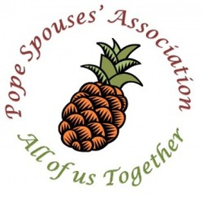

Contact Information
Full Name:
Last |  |  |  |  |  |  |  |  |  | First |  |  |  | New Member?
Address:
 |  |  | Street Address City |  |  |  |  |  |  |  |  |  |  | ZIP Code
 |  |  |  |  |  |  |  |  |  |  |  |  |  | Yes No
 |  |  | Spouse |  |  |  |  |  |  | Squadron or Unit |  |  |  | Deployed?
Phone: |  |  |  | ( ) |  |  |  |  | Email:
Birthday Month/Day: |  |  |  |  |  |  |  |  |  | May PSA post this on their website? Yes No

Voluntary Information
Special Skills or Interests:

Are you interested in serving as a PSA Board member?
 | Exec. Council – President |  |  |  |  |  |  | Historian |  |  |  |  | Committee – Scholarship
 | Exec. Council – Vice President |  |  |  |  |  |  | Committee - Membership |  |  |  |  | Committee – Social
 | Exec. Council - Secretary |  |  |  |  |  |  | Committee - Newsletter |  |  |  |  | Committee – Thrift Shop
 | Exec. Council - Parlimentarian |  |  |  |  |  |  | Committee - Publicity |  |  |  |  | Committee – Ways and Means
Volunteer needs:
 | Baking |  |  |  |  |  |  | St. Nicholas Boot Drop |  |  |  |  | Other
 | Crafts |  |  |  |  |  |  | Thrift Shop |  |  |  |  | Other
Verification:
Dues Paid: |  |  |  |  | Aug – May $30 Aug – Dec $15 Jan - May $15
Signature/Date:

